Abstract form for:
Matrix Nexus: From Molecular Foundations to Life
The German-Nordic Join ECM Meeting in Freiburg, Germany
March 26 to 28, 2025
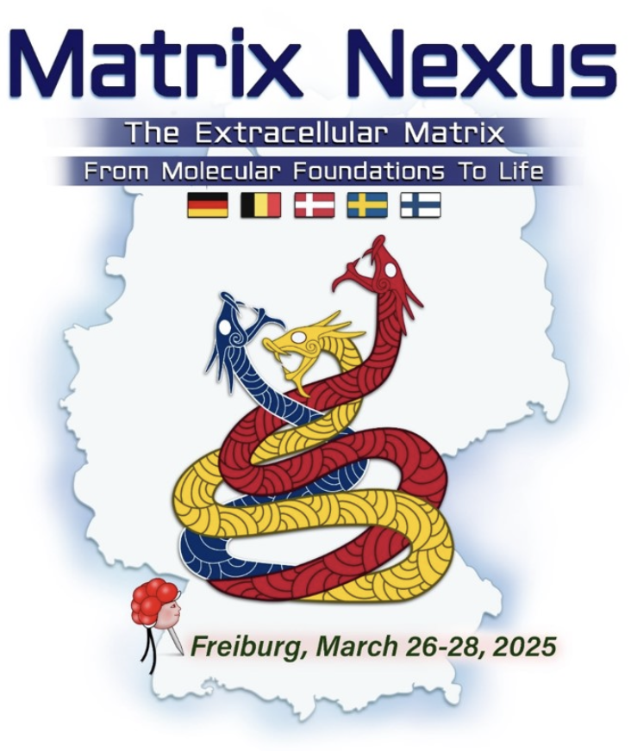
Short oral presentations (10 min + 5 min discussion) will be selected from the submitted abstracts by a scientific committee.

Several Poster Prizes will be given. Prize money will be doubled for members of the DGMB (to become a member: http://www.matrixbiologie.de/)

Please use the text box on the next page for your abstract. Please keep with the suggested format. Leave the inserted text box (top left) free for the abstract number which will be edited by the meeting organizers.

Please save your abstract and upload a pdf file via http://www.matrixbiologie.de/

Late breaking abstracts: deadline March 14th, 2025

 Matrix Nexus: 26.-28.03.2025, Freiburg
Title [Arial bold, 16pt, line space: 1.5]
Authors:
[Arial, 12 pt; single-spaced], please underline the presenting author

Introduction: [Arial italics, 11 pt]:
Text [Arial, 11 pt; single-spaced9]
]

Methods: [Arial italics, 11 pt]:
Text [Arial, 11 pt; single-spaced]
]

Results: [Arial italics, 11 pt]:
Text [Arial, 11 pt; single-spaced]
]

Discussion: [Arial italics, 11 pt]:
Text [Arial, 11 pt; single-spaced]
]

References: [Arial italics, 10 pt]:
Text [Arial, 10 pt; single-spaced]
]

